accessed using the internet, making the trend of energy consumption visible to the corresponding consumer thus giving awareness to the consumer’s electric bill.

This study aims to fabricate a device that reads the kilowatt-hour consumption of a single phase system and the database used to display and save the monitored values. The device is connected to a wireless system using Xbee Pro which sends wirelessly the data to another Xbee Pro for the logging and monitoring of the consumption in real time basis.

The researchers also include the automation of the paperless electric bill assessment through the use of GSM module. The server will send a notice of electric bill before the scheduled payment of the consumer. Beyond the schedule, the server will perform automatic disconnection.

* 1. **Statement of the problem**

The purpose of this study is to develop a system that is able to monitor power consumption with this being the main concern the following questions have been formulated:

1. What kind of sensors will be employed for power consumption data acquisition?

2.What kind of wireless communication is employed for data transmission?

3. What data logging mechanism is employed to store received data?

4. What medium of communication is employed to allow the user to access their power consumption?

5. What wireless transmission protocol is employed to transmit recurring monthly billing updates?

6. What mechanism is employed for automatic disconnection and connection?

7. What method is used to test the accuracy of the system?

* 1. **Objectives of the Study**
     1. **General Objectives:**

The general objectives of this project are:

1. To fabricate a prototype of an energy meter that wirelessly sends the energy reading to the database accessible through internet; and

1. To develop a system in automating the energy bill assessment with automatic disconnection beyond due date.
   * 1. **Specific Objectives:**

The specific objectives of this study are to:

1. Use a wireless communication through zigbee pro from energy meter to the server and vice versa.
2. Create a web page that is accessible by everyone through the use of internet that displays energy consumption and the equivalent bill in real time.
3. Evaluate the accuracy of the made prototype in reference to the available digital power meter.
4. Utilize a GSM for the paperless bill.

**1.4 Significance of the Study**

This study has three significant aspects. First, this study investigates the replacement of the traditional electric energy meter to an electric energy meter that will wirelessly send the energy reading to the server thus benefitting the utility company. Utility company will no longer send electric personnel to every residential house just to read every resident’s energy consumption per month since this project allows the utility companies to collect the reading in the server site. This project will alleviate company’s labor cost, collection time, and above all, late payment can be avoided since it involves an automatic disconnection beyond due date of the payment.

Second, this project includes the display of the current bill to the energy meter. Since the residents will be able to regularly check the bill as a result of their energy consumption per day, awareness of energy consumption is very possible. This project will also let the residents to regularly check their energy consumption which includes the current bill.

Third, this project provides a server to collect the data sent by the individual energy meter. The electric personnel assigned in the gathering of the monitored data will only go to the respective server site if necessary. Additionally, since this project involves the automatic disconnection, the safety of the electric personnel to disconnect resident’s power is now secured.

**1.5 Limitations of the Study**

Although the project has reached its aims, there are some unavoidable limitations.

First, because of the time and budget limit, this project will only provide one prototype of energy meter that the researchers carefully design and fabricated this project will only provide few prototypes of energy meter that the researchers carefully design and fabricate to meet maximum efficiency in order to demonstrate the receiving of data to the server sequentially. Mesh networking is demonstrated through the aid of a software simulation.

Second, because of its availability, the microcontroller used is atmega328p, a high-performance Atmel picoPower 8-bit AVR RISC-based microcontroller.

Third, because of its functionality, the data acquisition is done through the ADE7753 energy meter Integrated Circuit and the data is transmitted using a Xbee-Pro module as an RF transceiver.

Lastly, because of its application, the system is only applicable to a single phase source and a residence having an available load/s which draw/s a maximum current of 10A since this is the maximum current tested so far. This study is for demonstration purposes only. Long distance transmission and wider picture of a network are beyond the scope of this paper.

**1.6 Definition of Terms**

**Power** (symbol: *P*) - in physics, is defined as the amount of energy consumed per unit time. In the MKS system, the unit of power is the joule per second (J/s), known as the watt (in honor of James Watt, the eighteenth-century developer of the steam engine). For example, the rate at which a light bulb converts electrical energy into heat and light is measured in watts—the more wattage, the more power, or equivalently the more electrical energy is used per unit time.

**Serial Peripheral Interface** - is a synchronous serial data protocol used by microcontrollers for communicating with one or more peripheral devices quickly over short distances. It can also be used for communication between two microcontrollers.

**Bootloader** - is a computer program that loads the main operating system or runtime environment for the computer after completion of self-tests. The computer term boot is short for bootstrapor bootstrap load and derives from the phrase to pull oneself up by one's bootstraps.

**In-System Programming (ISP)** - is the ability of some programmable logic devices, microcontrollers, and other embedded devices to be programmed while installed in a complete system, rather than requiring the chip to be programmed prior to installing it into the system. The primary advantage of this feature is that it allows manufacturers of electronic devices to integrate programming and testing into a single production phase, and save money, rather than requiring a separate programming stage prior to assembling the system. This may allow manufacturers to program the chips in their own system's production line instead of buying preprogrammed chips from a manufacturer or distributor, making it feasible to apply code or design changes in the middle of a production run.

**Firmware** - is a software program or set of instructions programmed on a hardware device. It provides the necessary instructions for how the device communicates with the other computer hardware Firmware is typically stored in the flash ROM of a hardware device. While ROM is "read-only memory," flash ROM can be erased and rewritten because it is actually a type of flash memory. Firmware can be thought of as "semi-permanent" since it remains the same unless it is updated by a firmware updater.

**Baud Rate** - The baud rate of a data communications system is the number of symbols per second transferred. A symbol may have more than two states, so it may represent more than one binary bit (a binary bit always represents exactly two states). Therefore the baud rate may not equal the bit rate, especially in the case of recent modems, which can have (for example) up to nine bits per symbol.

**1.7 Theoretical Framework**

**1.7.1 ATMEGA328p**

The high-performance Atmel picoPower 8-bit AVR RISC-based microcontroller combines 32KB ISP flash memory with read-while-write capabilities, 1024B EEPROM, 2KB SRAM, 23 general purpose I/O lines, 32 general purpose working registers, three flexible timer/counters with compare modes, internal and external interrupts, serial programmable USART, a byte-oriented 2-wire serial interface, SPI serial port, a 6-channel 10-bit A/D converter (8-channels in TQFP and QFN/MLF packages), programmable watchdog timer with internal oscillator, and five software selectable power saving modes. The device operates between 1.8-5.5 volts. [6]

By executing powerful instructions in a single clock cycle, the device achieves throughputs approaching 1 MIPS per MHz, balancing power consumption and processing speed. [6]

The researchers use the Thin Quad Flat Package (TQFP) of atmega328p (**Appendix D.13**).

**1.7.2 Atmel Studio 6.1 Integrated Development Environment**

Atmel® Studio 6 is the integrated development platform (IDP) for developing and debugging Atmel ARM Cortex™-M and Atmel AVR microcontroller (like ATMEGA328p) based applications. The Atmel Studio 6 IDP gives a seamless and easy-to-use environment to write, build and debug applications written in C/C++ or assembly code. [7]

This is the software used by the researchers to run and build the programs intended for the standalone atmega328p(**Appendix B.1**).

**1.7.3 Avrdude (AVR Downloader or UploaDEr)**

AVRDUDE is a utility to download, upload, and/or manipulate the ROM and EEPROM contents of AVR microcontrollers using the in-system programming technique (ISP). It comes bundled with WinAVR which includes AVRDUDE, having command-line driven user interface for all downloading and uploading features (including handling fuse bytes), for easy automation. [8]

**1.7.4 Arduino Integrated Development Environment (IDE) v1.0.5**

Arduino is an open source electronics prototyping platform based on flexible. It is intended in creating interactive objexcts or environments. [9]

The open-source Arduino environment makes it easy to write code and upload it to the I/O board. It runs on Windows, Mac OS X, and Linux. The environment is written in Java and based on Processing, avr-gcc, and other open source software. [9]

The researchers used this software to upload the ISP program to the Arduino UNO board, telling the arduino UNO board that the next upload is not intended for its use (**Appendix B.2**)

**1.7.5 Arduino UNO**

Arduino UNO is a single-board microcontroller, intended to make the application of interactive objects or environments more accessible. The hardware consists of an open-source hardware board designed around an 8-bit Atmel AVR microcontroller (ATMEGA328p). Pre-programmed into the on-board microcontroller chip is a boot loader that allows uploading programs into the microcontroller memory without needing a chip (device) programmer [9] (**Appendix C.1**).

In relevance to the project, the Arduino UNO is used as an In System Programmer (ISP) of the stand-alone ATMEGA328p.

**1.7.6 ADE7753**

This product is from Analog Devices which is a single-phase multifunction metering Integrated Circuit (IC) with di/dt Sensor Interface. The ADE7753 features proprietary ADCs and DSP for high accuracy over large variations in environmental conditions and time. It has all the requirements to perform active, reactive, and apparent energy measurements, line voltage period measurement, and rms calculation on the voltage and current. [5]

The ADE7753 provides a serial interface to read data. It uses Serial Peripheral Interface to communicate with the microcontroller used. The researchers choose this IC because it is suitable for the project’s application which is for the single phase loadings [5] (**Appendix D.1**).

**1.7.6.1 Theory of Operation**

The ADE7753 has two fully differential voltage input channels. The maximum differential input voltage for input pairs V1P/V1N and V2P/V2N is ±0.5 V. In addition, the maximum signal level on analog inputs for V1P/V1N and V2P/ V2N is ±0.5 V with respect to AGND. Each analog input channel has a programmable gain amplifier (PGA) with possible gain selections of 1, 2, 4, 8, and 16. The gain selections are made by writing to the gain register (**Appendix D.2**). Bits 0 to 2 select the gain for the PGA in Channel 1, and the gain selection for the PGA in Channel 2 is made via Bits 5 to 7. **Appendix D.3** shows how a gain selection for Channel 1 is made using the gain register. [5]

In addition to the PGA, Channel 1 also has a full-scale input range selection for the ADC. The ADC analog input range selection is also made using the gain register. As mentioned previously, the maximum differential input voltage is 0.5 V. However, by using Bits 3 and 4 in the gain register, the maximum ADC input voltage can be set to 0.5 V, 0.25 V, or 0.125 V. This is achieved by adjusting the ADC reference. **Appendix D.4** summarizes the maximum differential input signal level on Channel 1 for the various ADC range and gain selections. [5]

It is also possible to adjust offset errors on Channel 1 and Channel 2 by writing to the offset correction registers, CH1OS and CH2OS, respectively. These registers allow channel offsets in the range ±20 mV to ±50 mV (depending on the gain setting) to be removed. Channel 1 and 2 offset registers are signed magnitude coded. A negative number is applied to the Channel 1 offset register, CH1OS, for a negative offset adjustment. Note that the Channel 2 offset register is inverted. A negative number is applied to CH2OS for a positive offset adjustment. It is not necessary to perform an offset correction in an energy measurement application if HPF in Channel 1 is switched on. [5]

**1.7.6.2 Channel 1 ADC**

**Appendix D.5** shows the ADC and signal processing chain for Channel 1. In waveform sampling mode, the ADC outputs a signed two’s complement 24-bit data-word at a maximum of 27.9 kSPS (CLKIN/128). With the specified full-scale analog input signal of 0.5 V (or 0.25 V or 0.125 V the ADC produces an output code that is approximately between 0x2851EC (+2,642,412d) and 0xD7AE14 (–2,642,412d). [5]

The ADE7753 simultaneously calculates the rms values for Channel 1 and Channel 2 in different registers. **Appendix D.6** shows the detail of the signal processing chain for the rms calculation on Channel 1. The Channel 1 rms value is processed from the samples used in the Channel 1 waveform sampling mode. The Channel 1 rms value is stored in an unsigned 24-bit register (IRMS). One LSB of the Channel 1 rms register is equivalent to one LSB of a Channel 1 waveform sample. The update rate of the Channel 1 rms measurement is CLKIN/4. [5]

With the specified full-scale analog input signal of 0.5 V, the ADC produces an output code that is approximately ±2,642,412d. The equivalent rms value of a full-scale ac signal are 1,868,467d (0x1C82B3). The current rms measurement provided in the ADE7753 is accurate to within 0.5% for signal input between full scale and full scale/100. **Appendix D.7** shows the settling time for the IRMS measurement, which is the time it takes for the rms register to reflect the value at the input to the current channel. The conversion from the register value to amps must be done externally in the microprocessor using an amps/LSB constant. To minimize noise, synchronize the reading of the rms register with the zero crossing of the voltage input and take the average of a number of readings. [5]

**1.7.6.3 Channel 2 ADC**

In Channel 2 waveform sampling mode (MODE[14:13] = 1,1 and WSMP = 1), the ADC output code scaling for Channel 2 is not the same as Channel 1. The Channel 2 waveform sample is a 16-bit word and sign extended to 24 bits. For normal operation, the differential voltage signal between V2P and V2N should not exceed 0.5 V. With maximum voltage input (±0.5 V at PGA gain of 1), the output from the ADC swings between 0x2852 and 0xD7AE (±10,322d). However, before being passed to the wave-form register, the ADC output is passed through a single-pole, low-pass filter with a cutoff frequency of 140 Hz. [5]

Channel 2 has only one analog input range (0.5 V differential). Like Channel 1, Channel 2 has a PGA with gain selections of 1, 2, 4, 8, and 16. For energy measurement, the output of the ADC is passed directly to the multiplier and is not filtered. An HPF is not required to remove any dc offset since it is only required to remove the offset from one channel to eliminate errors due to offsets in the power calculation. When in waveform sampling mode, one of four output sample rates can be chosen by using Bits 11 and 12 of the mode register. The available output sample rates are 27.9 kSPS, 14 kSPS, 7 kSPS, or 3.5 kSPS. The interrupt request output signals that a sample is available by going active low. The timing is the same as that for Channel 1 [5] (**Appendix D.7**).

This Channel 2 rms estimation is done in the ADE7753 using the mean absolute value calculation, as shown. The Channel 2 rms value is processed from the samples used in the Channel 2 waveform sampling mode. The rms value is slightly attenuated because of LPF1. Channel 2 rms value is stored in the unsigned 24-bit VRMS register. The update rate of the Channel 2 rms measurement is CLKIN/4. With the specified full-scale ac analog input signal of 0.5 V, the output from the LPF1 swings between 0x2518 and 0xDAE8 at 60 Hz. The equivalent rms value of this full-scale ac signal is approximately 1,561,400 (0x17D338) in the VRMS register. The voltage rms measurement provided in the ADE7753 is accurate to within ±0.5% for signal input between full scale and full scale/20 [5] (**Appendix D.9**).

**Appendix D.7** Table 1.3 shows the settling time for the VRMS measurement, which is the time it takes for the rms register to reflect the value at the input to the voltage channel.

The conversion from the register value to volts must be done externally in the microprocessor using a volts/LSB constant. Since the low-pass filtering used for calculating the rms value is imperfect, there is some ripple noise from 2ω term present in the rms measurement. To minimize the noise effect in the reading, synchronize the rms reading with the zero crossings of the voltage input. [5]

**1.7.7 Xbee Pro**

The XBee and XBee-PRO OEM RF Modules were engineered to meet IEEE 802.15.4 standards and support the unique needs of low-cost, low-power wireless sensor networks. The modules require minimal power and provide reliable delivery of data between devices. The modules operate within the ISM 2.4 GHz frequency band and are pin-for-pin compatible with each other. [2]

The researchers choose this kind of wireless communication since it can perform a peer to peer topology (see **Appendix D.10**).

**1.7.8 Cadsoft Eagle PCB Design Software**

The award winning EAGLE is a powerful and flexible PCB design software offering high level functionality of expensive commercial circuit board design software at a fraction of the cost. It runs on Linux, Mac and Windows and allows feature enhancement, such as simulation, data import and export and self-defined commands, through User Language Programs (ULP’s) which are partly integrated in EAGLE. [10]

The researchers have utilized this software for the design and layout of the project’s Printed Circuit Board (PCB). **Appendix B.3** shows how this software appears after execution.

**1.7.9 Serial Peripheral Interface Implementation**

The standard Serial Peripheral Interface uses a minimum of three line ports for communicating with a single SPI device (SPI slave), with the chip select pin (CS) is being always connected to the ground (enable). If more than one SPI devices is connected to the same bus, then we need four ports and use the fourth port (SS pin on the ATMega168 microcontroller) to select the target SPI device before starting to communicate with it (see **Appendix E.1**).

SPI peripheral use the shift register to transfer and receive the data, for example the master wants to transfer 0b10001101 (0x8E) to the slave and at the same time the slave device also wants to transfer the 0b00110010 (0×32) data to the master. By activating the CS (chip select) pin on the slave device, now the slave is ready to receive the data. On the first clock cycle both master and slave shift register will shift their registers content one bit to the left; the SPI slave will receive the first bit from the master on its LSB register while at the same time the SPI master will receive its first data from slave on its LSB register as shown at **Appendix E.2**.

Continuously using the same principal for each bit, the complete data transfer between master and slave will be done in 8 clock cycle. By using the highest possible clock allowed such as the Analog Devices SPI slave I/O device (10 MHz) than the complete data transfer between the microcontroller and this SPI I/O port could be achieve in 0.8 µs.

**1.7.10 Liquid Crystal Display (LCD)**

A liquid-crystal display (LCD) is a flat panel display, electronic visual display, or video display that uses the light modulating properties of liquid crystals. Liquid crystals do not emit light directly. It basically works on the concept of Light Polarization of a Liquid Crystal under the influence of an Electric Field. Every LCD contains a Back-Light behind the Liquid Crystal array, which acts as a light source. When an Electric Field is applied across certain fluids, it changes the way they allow light to pass through them, that is, it changes the orientation of the liquid crystal molecules as a result they do not allow light to pass through them. Hence, by applying suitable potential difference, we can control if light passes or doesn’t pass through the LCD pixels [11] (see **Appendix D.11**).

LCD 16×2 can be interfaced in two different modes:

* 8-bit Mode

In 8-bit mode pins from 7 to 14 (total 8 pins) are connected to eight I/O pins of microcontroller.. The advantage to operating in 8-bit mode is that the programming is a bit simpler and data can be updated more quickly.

* 4-bit mode

In 4-bit mode pins from 11 to 14 (total 4 pins) are connected to four I/O pins of microcontroller. The main reason to operate in 4-bit mode is to save four I/O pins.

Programming the LCD in Atmel Studio requires the basic knowledge of the LCD, its command and instruction sets. In this project, the researchers use 4-bit mode, but it is nearly the same as the 8-bit mode to implement.

**1.7.11 Current Transformer**

A Current transformer (CT) is an instrument transformer in which the secondary current is substantially proportional to primary current and differs in phase from it by ideally zero degree. It is used for measurement of alternating electric currents. Current transformers, together with voltage transformers (VT) (potential transformers (PT)), are known as instrument transformers. When current in a circuit is too high to apply directly to measuring instruments, a current transformer produces a reduced current accurately proportional to the current in the circuit, which can be conveniently connected to measuring and recording instruments. It isolates the measuring instruments from what may be very high voltage in the monitored circuit. They are commonly used in metering and protective relays in the electrical power industry [4] (see **Appendix D.12**).

Unlike the voltage or power transformer, the current transformer consists of only one or very few turns as its primary winding. This primary winding can be of either a single flat turn, a coil of heavy duty wire wrapped around the core or just a conductor or bus bar placed through a central hole. [4]

The secondary winding may have a large number of coil turns wound on a laminated core of low-loss magnetic material which has a large cross-sectional area so that the magnetic flux density is low using much smaller cross-sectional area wire, depending upon how much the current must be stepped down. [4]

Current transformers can reduce or "step-down" current levels from thousands of amperes down to a standard output of a known ratio. Thus, small and accurate instruments and control devices can be used with CT's because they are insulated away from any high-voltage power lines. There is a variety of metering applications and uses for current transformers such as with wattmeter's, power factor meters, watt-hour meters, protective relays, or as trip coils in magnetic circuit breakers, or MCB's. [4]

The current transformer used in this project has a relationship between the primary and secondary currents of 1000/1.When 1000 Amps is flowing in the primary winding, it will result in 1 Amp flowing in the secondary winding. By increasing the number of secondary windings, N2, the secondary current can be made much smaller than the current in the primary circuit being measured. In other words, as N2 increases, I2 goes down by a proportional amount. It follows an equation of

**1.7.11.1 Burden Resistor**

The secondary load of a current transformer is usually called the "burden" to distinguish it from the load of the circuit whose current is being measured.

The value of burden resistor is carefully chosen and designed to have a maximum current input for CT but having a constraint of voltage induced not to exceed from 0.5V which is the input voltage capacity of the ADE7753 to handle.

**1.7.12 Typical Electric Meter**

Electric Meter, or Watt-hour Meter, an instrument that measures the amount of electric energy used by a consumer. The meter is calibrated in kilowatt-hours. One kilowatt-hour is the amount of electric energy required to provide 1,000 watts of power for a period of one hour. (Ten 100-watt light bulbs left on for one hour consume one kilowatt-hour of electric energy).

An electric power company uses electric meters to measure the amount of electricity consumed by each of its customers. The power company installs an electric meter near where its power lines enter a customer's building. It reads the meter periodically and charges the customer for the amount of electricity used.

The most common type of electric meter is essentially an electric induction motor that drives a series of geared wheels connected to indicators on the meter's face. This type of meter is designed for use with alternating current. It contains two electromagnets and a metal disk that is free to rotate between them. One electromagnet is powered directly by current from the incoming power lines; the other, by current drawn through the building's electrical circuits. The interaction of the magnetic fields produced by the coils causes the disk to rotate. Two permanent magnets near the disk's edge brake the disk in such a way that the speed of rotation is proportional to the amount of current drawn. As the disk rotates, it turns the series of geared wheels connected to the indicators on the meter's face.

Electronic watt-hour meters use solid-state circuits that produce electrical signals whose frequency or strength is proportional to the voltage and current being used. These signals are converted into energy measurements recorded by mechanical or electronic indicators. Electronic watt-hour meters are generally more expensive than electromechanical models, but are more accurate. They can provide such features as the ability to record separately the energy consumed during different times of day and the ability to report meter readings by means of signals sent through the power lines to the power company.

**1.7.13 Surface Mount Device (SMD)**

Almost all of the resistors and capacitors used are in surface mount package.

Surface-mount technology (SMT) is a method for producing electronic circuits in which the components are mounted or placed directly onto the surface of printed circuit boards (PCBs). An electronic device so made is called a surface-mount device (SMD). In the industry it has largely replaced the through-hole technology construction method of fitting components with wire leads into holes in the circuit board. Both technologies can be used on the same board for components not suited to surface mounting such as large transformers and heat-sinked power semiconductors. [12]

An SMT component is usually smaller than its through-hole counterpart because it has either smaller leads or no leads at all. It may have short pins or leads of various styles, flat contacts, a matrix of solder balls (BGAs), or terminations on the body of the component. [12]

**1.7.14 Meteor.js**

Meteor is an [open-source](http://en.wikipedia.org/wiki/Open-source) [JavaScript](http://en.wikipedia.org/wiki/JavaScript) [web application framework](http://en.wikipedia.org/wiki/Web_application_framework). It was first introduced in December 2011 under the name Skybreak. At its core is the [Distributed Data Protocol](http://en.wikipedia.org/wiki/Distributed_Data_Protocol). Its release was the largest in [Hacker News](http://en.wikipedia.org/wiki/Hacker_News) history. Among open source projects, it is also the third most starred [GitHub](http://en.wikipedia.org/wiki/GitHub) repository in 2012. [Meteor](http://meteor.com/) is at the forefront of a new wave of frameworks that make building web apps easier, simpler, and faster. [14]

Not only is Meteor entirely real-time (meaning any change to your database is automatically reflected live in the browser), but the fact that it uses JavaScript on both the client and server means that you won't have to juggle with multiple languages and environments anymore. [14]

**1.7.15 Node.js**

Node.js is a platform built on [Chrome's JavaScript runtime](http://code.google.com/p/v8/) for easily building fast, scalable network applications. Node.js uses an event-driven, non-blocking I/O model that makes it lightweight and efficient, perfect for data-intensive real-time applications that run across distributed devices. [13]

Node.js is a software platform for [scalable](http://en.wikipedia.org/wiki/Scalability) server-side and networking applications. Node.js applications are written in [JavaScript](http://en.wikipedia.org/wiki/JavaScript), and can be run within the Node.js runtime on [Windows](http://en.wikipedia.org/wiki/Microsoft_Windows), [Mac OS X](http://en.wikipedia.org/wiki/Mac_OS_X) and Linux with no changes. [13]

Node.js applications are designed to maximize throughput and efficiency, using non-blocking I/O and asynchronous [events](http://en.wikipedia.org/wiki/Event-driven_architecture). Node.js applications run [single-threaded](http://en.wikipedia.org/wiki/Single_threading), although Node uses multiple threads for file and network events. [13]

Node.js internally uses the [Google V8](http://en.wikipedia.org/wiki/V8_(JavaScript_engine)) JavaScript engine to execute code, and a large percentage of the basic modules are written in JavaScript. Node.js contains a built-in HTTP server library, making it possible to run a web server without [Apache](http://en.wikipedia.org/wiki/Apache_(web_server)) or [Lighttpd](http://en.wikipedia.org/wiki/Lighttpd). Unlike most JavaScript programs, Node.js is not executed in a web browser, but instead as a [server-side JavaScript](http://en.wikipedia.org/wiki/Server-side_JavaScript) application. Node.js implements some [CommonJS](http://en.wikipedia.org/wiki/CommonJS) specifications. It also provides a [REPL](http://en.wikipedia.org/wiki/Read%E2%80%93eval%E2%80%93print_loop) environment for interactive testing. [13]

**1.7.16 Socket IO**

Socket.IO aims to make realtime apps possible in every browser and mobile device, blurring the differences between the different transport mechanisms. It's care-free realtime 100% in JavaScript. [15]

Socket.IO is a [JavaScript](http://en.wikipedia.org/wiki/JavaScript) library for realtime [web applications](http://en.wikipedia.org/wiki/Web_application). It has two parts: a [client-side](http://en.wikipedia.org/wiki/Client-side) library that runs in the [browser](http://en.wikipedia.org/wiki/Web_browser), and a [server-side](http://en.wikipedia.org/wiki/Server-side) library for [node.js](http://en.wikipedia.org/wiki/Node.js). Both components have a nearly identical [API](http://en.wikipedia.org/wiki/Application_programming_interface). Like node.js, it is [event-driven](http://en.wikipedia.org/wiki/Event-driven_architecture). [15]

Socket.IO primarily uses the [WebSocket](http://en.wikipedia.org/wiki/WebSocket) protocol, but if needed can fallback on multiple other methods, such as [Adobe Flash](http://en.wikipedia.org/wiki/Adobe_Flash) sockets, [JSONP](http://en.wikipedia.org/wiki/JSONP)polling, and [AJAX long polling](http://en.wikipedia.org/wiki/Comet_(programming)#Ajax_with_long_polling), while providing the same interface. Although it can be used as simply a [wrapper](http://en.wikipedia.org/wiki/Wrapper_library) for WebSocket, it provides many more features, including broadcasting to multiple sockets, storing data associated with each client, and [asynchronous I/O](http://en.wikipedia.org/wiki/Asynchronous_I/O). It can be installed with the [npm](http://en.wikipedia.org/wiki/Npm_(software)) (node packaged modules) tool. [15

**1.7.17 CA8220 Power Analyzer**

This is the apparatus being used to compare the data acquired from the prototype if it inclines to the standard of a power analyzer (see **Appendix F** Figure 1.12).

**CHAPTER II**

**REVIEW OF RELATED LITERATURE**

A survey of related studies was undertaken by the researchers to get an insight into the work that has already been in the field of study and to get suggestion regarding the ways and means for the collection of relevant data and interpretation of results. The study reviewed focuses on the special projects done by the alumni of Mindanao State University-Iligan Institute of Technology about logging data through wireless communications to the database and journals that the researchers think might be a great help as a reference for the success of the project. A brief description and part of methodology of each system are provided. However, the reader is referred to the given specific references for further understanding and for the benefit of acquiring more information.

**2.1 Research on Zigbee Wireless Meter Reading System in Opnet Simulator**

This journal is found in the springerlink site. The paper aims to evaluate the performance of a ZigBee wireless meter reading system using Opnet. First, a scheme of distributed meter reading system is proposed. In order to simulate the real system, an energy module special for CC2530 is added in Opnet. Then the necessary parameter configurations are considered. The simulation environment of the proposed system is set up. According to the monitored global and local statistics, it comes to the conclusion that the scheme has the distinguishing characteristics of the smaller end-to-end delay, the few packet loss as well as lower energy consumption and can be well applied in the factual meter reading system.

# 2.2 Wireless Energy Meters for Distributed Energy Efficiency Applications

This journal is found in the springerlink site. This work presents a pervasive power usage monitoring system based on a wireless energy meter network which can be easily deployed to monitor energy consumptions of appliances in households or computing hardware and related infrastructures in data centers. Two wireless energy meters, as base units of a sensor network, has been designed and developed: a power adapter energy meter and a clamp based energy meter. The adapter is to be employed for monitoring devices that can be plugged to a power outlet while the clamp for heavy loads and devices that cannot be safely or easily unplugged. A base station receives data gathered through all sensors of the network, acting as a gateway to the internet. Ad-hoc web based GUIs provide users with relevant information about real time and aggregated energy consumptions in the selected application.

**2.3 MaCE Wireless Voltage and Current Monitoring System**

A special project of Jed Jason Chiu, Jean Ederango, and Ara Reyna D. Mamon from Mindanao State University-Iligan Institute of Technology, batch 2010. This special project develops a wireless monitoring system and data logger which displays the voltage and current values measured over a three phase load in real time. It uses two-watt meter method to get the information necessary. It utilizes the ADE7758 energy monitoring chip for monitoring these parameters which is connected to a MCU for data acquisition and writes to a SD card for data retention in case of power failures. The researchers of this project intend to fabricate a simple device which can be used for research or study purposes which one focused on the behavior of these parameters from any specific electrical unit. For quick reference, the device is connected to a wireless module for real-time monitoring through a hyper-terminal and interpretation of the logged data in the SD card. In addition, the device has a plotting assistance for the analysis of the behavior of the logged data.

This project has one three phase line connected to the development board. The device creates a file that contains the data recorded on a 24-hour basis and stores these documents in an SD card through ATMEGA128. Each text file is formatted in FAT32 and corresponds to a 24-hour long data log; the file contains the magnitude of the current and voltage in all three phases, and the exact time of the day by which the data is taken. The sampling rate of the logged data is every 20 seconds.

**2.4 LIPTONDRON: A Real Time Wireless Energy Utilization Monitoring System**

A Special Project of Rey Anthony Aguirre, Ydron Paul Amarga and Philip Lim from Mindanao State University-Iligan Institute of Technology, batch 2010. This project improves the traditional way of electrical energy utilization monitoring by developing a wireless Ethernet based energy utilization system. Three phase electrical energy data is acquired using two wattmeter method implemented with current transformers for the current channel and voltage dividers for the voltage channel. The voltage and current signals are fed to an ADE7758 energy metering integrated circuit where an ATMEGA32 microprocessor would request energy data. Collected information is then wirelessly transmitted to the server through W5100, an Industrial Scientific and Medical Band (ISM) transceiver. Using a WIZ810MJ network interface module, the energy data is accessed using Hypertext Transfer Protocol(HTTP) requests from a browser deployed on any end system in the local area network. After a valid request is received by the embedded web server, total active energy, total reactive energy, power factor and data request time are made available in the browser and are kept updated by using Asynchronous Javascript and XML (AJAX). Tabulated energy data is also provided, the user sets a time span and on every end of a time span the server automatically logs the current time, accumulated active energy, accumulated apparent energy and power factor on a dynamic expanding table.

**CHAPTER III  
METHODOLOGY**

**3.1 System Requirements**

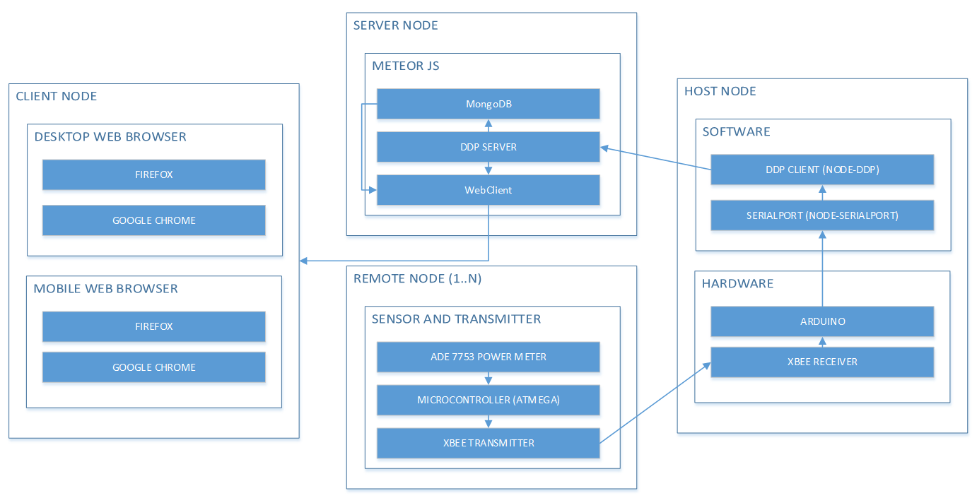The design involves the clear separation between Nodes with each node having a specific function. The remote node is a hardware device which includes the Power Meter using ADE7753, the ATMEGA328p Microcontroller and the Xbee Transmitter Sub Modules. The Host Node acts as a consolidation point of multiple Remote Nodes. It has an Xbee Receiver and the necessary software to send consolidated data to Server Node. The server Nodes carries the software necessary to store all data received from Multiple Host Nodes. The Client Node or the End User can then browse using a Web Browser the available data from the Server Node. Figure 3.1 shows how the framework looks like.

**Figure 3.1 System Level Overview**

Each individual Remote Node and Host Node has an ID assigned to them. There may be multiple Remote Nodes gathered around the vicinity of each Host Node. A set of Remote Nodes can send their data to a single Host Node. In case of a very large geographical area where only a few blocks are populated, an entire block area may be managed by one Host Node, and each house in a single block area may have individual Remote Nodes. The Host Node will be responsible of sending data to the server Node via Internet.

**3.2 Design Process**

The overall system is designed with emphasis in cost and practical application but effective and reliable performance and functionality. The process of design requires careful planning and searching for the most appropriate performance. The process design flow chart for the Smart Energy Monitoring and Control System for Residential Application is shown in Figure 3.2.

Research, Investigating and Planning

Hardware Design Process

Firmware Design Process

Software Design Process

Synchronization, Testing and Debugging

**Figure 3.2** Block Diagram of the System

**3.3 Research, Investigating and Planning**

Since the researchers are dealing with electricity in this project, a thorough research should be done before implementing the hardware design for safety purposes. Implementing the hardware without careful precautions could lead to damage of property.

The researchers have to go to numerous sites given by Google in order to gain resources relevant to the study. One important topic that the researchers have to dig in is the safety connection of the device to the main voltage. This is very crucial since the return current of the main voltage should be taken care of. It should not be tied to the other grounds of the devices especially to the microcontroller used to avoid killing the other components connected like the laptop.

Another thing to investigate is the circuitries of the ADE7753. This requires many circuitries in order for this device to run smoothly. The circuitries before the ADE7753 consist of voltage divider, low pass filters and series resistors must be implemented first in the universal Printed Circuit Board (PCB) to make sure that it is suitable for the capacity of the device involved. Its output is displayed through the oscilloscope to see clearly that it will not go beyond 0.5V which is the maximum voltage capacity of the ADE7753 device and that it is still a perfect sine wave.

**3.4 Hardware Design Process**

Figure 3.3 shows the general process performed by the hardware. The hardware developed revolves around the ADE7753 as the energy acquisition tool, the zigbee which allows the wireless communication between the prototype and the server and the ATMEGA328p that serves as the brain of the hardware.

LCD Display

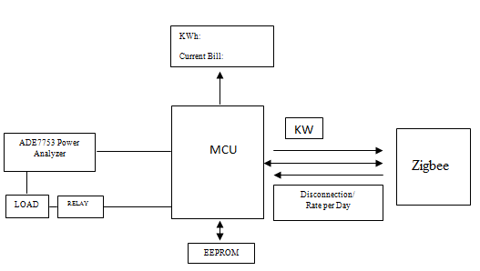

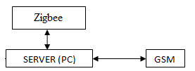

**Figure 3.3** Hardware Functionality

**3.4.1 ADE7753 Energy Meter Prototype**

For safety purposes, every single circuit attached to the components especially in the ADE7753 are all implemented and tested using the Universal PCB first before manufacturing the final PCB. The hardware developed is based on the evalboard and the example circuit found in the ADE7753 datasheet.

The circuits connected between V1P and V1N of the ADE7753 include the current transformer, burden resistor and the low pass filters. The burden resistor parallel to the current sensor is designed to have a maximum input current capacity with a limitation of 0.5V induced across it. It is also tested to verify the similarity of the actual and calculated value of the voltage induced across the burden resistor.

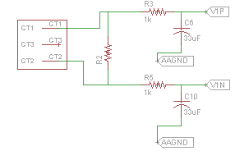

**Figure 3.4** ADE7753 Channel 1 Circuits

The main voltage or the AC voltage is connected to the V2P and V2N of ADE7753 via voltage dividers and low pass filters. Care should be observed when connecting the AC voltage to the hardware. Only the V2P is fed to the ac voltage, the V2N side is tied to the AGND as shown in Figure 3.5. The main neutral should not interact with the ground of all the components involved since it is not a ground or else your other components will be totally lost its posture.

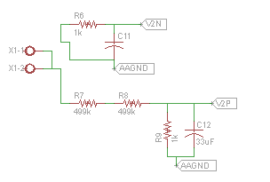

**Figure 3.5** ADE7753 Channel 2 Circuits

The researchers test the circuit having only one wire of 220V main voltage inputted to the V2P of ADE7753 and the ground fed to V2N is the ground of the 5V power supply. Test shows that the circuit with this setup works fine by the help of the oscilloscope for output display. (For the tests conducted in these two channels, watch the video inside the Compact Disc (CD) attached).

The schematic and PCB layout are both designed using Cadsoft Eagle Software. Choosing the software is the best choice since the prototype requires a double sided PCB and eagle is an easy to use tool in implementing it. For the full schematic and PCB layout, see the **Appendix A**.

In developing the prototype, the typical procedure is followed involving the presensitized PCB which can be bought from e-gizmo, exposing it to the ultraviolet light for few minutes, putting it to the developer afterwards before etching and drilling for the through hole components and vias.

**3.5 Firmware Design Process**

**3.5.1 Atmel Studio v6.1 Development**

The firmware loaded to ATMEGA328p is designed in Atmel Studio v6.1 which is a GCC (GNU Compiler Collection) C Executable File. The firmware design is developed to be modular as possible. The Atmel Microcontroller is used to coordinate the communications to the data collection servers via wireless Xbee communications and with the ADE7753 Power Meter circuitry through SPI. The team has made sure that the parts go in libraries so that it will be easier to scale the project with different parts and to remove some parts if necessary and with

maintainability of associated code in mind. This way the team can make sure that the project can be ready for actual production scale development.

Figure 3.6 specifies the firmware activities when executing. This allows anyone interested in the study to easily visualize what the program does throughout the session without referring anymore to the code. When executing the event handler (the one in colored, i.e., the block in color green situated at the main program), it jumps simultaneously into its subroutine (i.e., the block in green labeled as event). After the subroutine is serviced (or upon reaching the block labeled return), it goes back to where it has left off in the main program and execute the rest of the process.

ADE7753 Enabled by clearing PORTB2

(deassert the PORT)

ADE7753 Enabled by clearing PORTB2

(deassert the PORT)

Intialize I/O Ports, SPI communication, Baud Rate, etc

Write Initial Data to ADE7753 registers

Reg = 0x00|Reg

(to indicate read operation)

Reg = 0x80|Reg

(to indicate write operation)

*SPDR = reg

*SPDR = reg

delay

*SPIF in *SPSR

0

0

*SPIF in *SPSR

Read data from ADE7753 register

1

Transmit data wirelessly

N number of bytes that the register can store

N number of bytes that the register can store

1

True

While

i != N

True

While

i != N

i is initially 0

i is initially 0

False

*SPDR = dummy data

*SPDR = *data_transmit

0

SPIF in SPSR

False

SPIF in SPSR

0

0

ADE7753 Disabled by setting PORTB2

(assert the PORT)

1

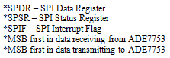

ADE7753 Disabled by setting PORTB2

(assert the PORT)

*data_receive = SPDR

1

**Figure 3.6** Program Flowchart for ADE7753 Acquisition

**3.5.2 ATMEGA328p Initialization**

Since the atmega328p is the brain and the controlling device of the system, it needs to be initialized to properly communicate to the connected peripheral.

In order for the microcontroller to communicate to ADE7753, the correct settings are initialized for the SPI protocol to function well. Since the project is coded in C programming, it is always necessary to refer to the datasheet of the microcontroller (for this case, it is the atmega328p) used for the initialization of Serial Peripheral Interface.

For the SPI to be enabled, the bit 6 of the SPI Control Register (SPCR) of the atmega328p is always asserted. This bit is the SPI Enable bit of the atmega328p. This bit must be set to enable any SPI operations.

Relevant to this project, the atmega328p is always set as a master device of the system and the connected peripherals are all slaves for Serial Peripheral Interfacing Communication Protocol. To make the atmega328p as a master device, the bit 4 of the SPI Control Register (SPCR) is always asserted. This bit 4 is the Master/Slave Select. This bit selects Master SPI mode when written to one.

When the SPI is configured as a Master, the user can determine the direction of Slave Select pin of the atmega328p, it can be an output or an input. The data direction of the MOSI (Master Out Slave In), MISO (Master In Slave Out), and SCK (Serial Clock) pins should also be configured. The team chose to make things simple and implemented the Slave Select pin as output by setting PORTB2 of the atmega328p. Basically, if Slave Select (SS) is configured as an output, the pin is a general output pin which does not affect the SPI system. The pin will just be driving the Slave Select of the SPI slave. MOSI and SCK pins are also set as output while the MISO pin is set as input as mandated in the atmega328p datasheet.

In the ADE7753 datasheet, the data is shifted out from the register on the falling edge of the clock and the clock is low when idle so atmega328p should be told about this. Dealing with this circumstance, the bit 3 of the SPCR is chosen to be cleared while bit2 is set. This bit 2 is the Clock Phase ( CPHA ) mode while the bit 3 is the Clock Polarity ( CPOL )mode. Setting the Clock Phase will let the atmega328p read the data of the ADE7753 during the next drop or rise of the clock while clearing the bit 3 will mean that the read will be on the falling edge of the clock. Figure 3.7 will illustrate this initialization.

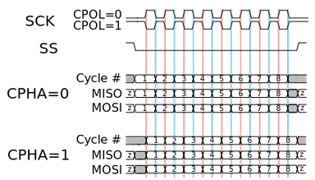

**Figure 3.7** SPI Timing Diagram

**3.5.3 Energy Data Acquisition**

The ADE7753 Energy Meter Chip is basically responsible for the energy parameters data acquisition. These parameters can be retrieved by calling its respective registers in the ADE7753 through Serial Peripheral Interface (SPI). The list of all the registers can be found in the ADE7753 Datasheet starting from page 52.

For write operation to the peripheral, the slave select pin of the atmega328p should be de-asserted first to initialize communication. This will be followed by defining the specific register to be written. This byte sized register has an MSB of 1 and will be transferred to the ADE7753 to instruct it that a write operation will take place in this register. This transfer will take place on the next falling edge of the SCK. All remaining register data are shifted into the ADE7753 on the falling edge of the clock pulses. When register data transmission is completed, the SPI Interrupt Flag (SPIF) bit in the SPI Status Register (SPSR) will be set. After the register data transfer follows the data to be written in the register. The data will be transferred one byte at a time. The transfer of every byte has a finite time of delay to occur as indicated in the ADE7753 datasheet. After the transmission of all the data, the SS pin will be brought to its idle state by asserting it.

The write and read operations are similar to each other. It only differs to the way the data are shifted out. During the data read operation from the peripheral, the MSB of the byte sized register is 0 to indicate read operation. Data is shifted out from the ADE7753 by defining a buffer first in the MCU. This buffer is any byte sized number and will be carried out from the MCU in the same interval with the content of the register being extracted from the ADE7753. The ADE7753 will receive the first bit from the MCU on its LSB register while at the same time the MCU will receive its first data from ADE7753 on its LSB register.

The received data from the content of the ADE7753 register will be processed by the MCU for the actual value conversion.

**3.5.4 Energy Data Transmission**

The data transmission in the project is done through the use of an Xbee Pro module to transmit the data from one node to the server or one node to another node if the data is not capable to be transmitted directly to the server due to limited distance capacity of the module. The Xbee Pro module communicates to the ATMEGA328p through a Universal Asynchronous and Synchronous serial Receiver and Transmitter (USART) at 9600 baud rate. The format for the data transmitted is the Client Identification Code first followed by the Host Identification Code (Server Identification Code) and finally the data acquired from the ADE7753. These data are synchronously transmitted and are separated by comma.

Data received

Check Destination

if desination != id

if desination == id

Check Source

recognize

If source == id

Source != id

ignore

Check source if already received

Yes

Write source to array sources [100] (save source)

No

resend

**Figure 3.8** Flowchart for Zigbee Communication

**3.6 Synchronization, Testing and Debugging**

**3.6.1 Programming standalone AVR**

This section will give everyone a step by step process on how to use the Arduino UNO board as ISP (In system Programmer) to program the ATMEGA328p or any AVR MCU.

To begin with, open the Arduino IDE, go to Files->Examples, and open ArduinoISP. Then from Tools -> Board select Arduino UNO, and from Tools->Programmer select AVR ISP or Arduino as ISP. Access Tools->Serial Port and write down the name of the port (ex. COM3) which is needed for the avrdude. Finally, press File->Upload to load ArduinoISP to Arduino UNO. This operation transforms Arduino UNO into an ISP Programmer telling it that the next receive codes is not for him.

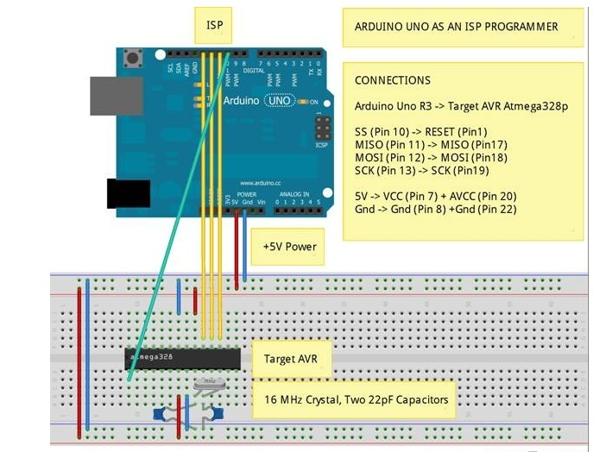

**Figure 3.9** Arduino UNO as ISP Connections

Connect the ISP pins of Arduino UNO to the ATMEGA328p as indicated in the figure 3.9. After wiring, write your source code to be uploaded in the microcontroller. The hex file generated upon compiling the code is used in the avrdude command lines to upload your code into the AVR microcontroller.

For example, if you have the PowerCmd, copy the codes (shown in the first line of Figure 3.10) and press enter, if not then you will manually enter this to the Command Prompt the m328p in the code is the microcontroller used in your project.

After pressing enter, the avrdude should display the message telling you that the Target AVR is accessible and can be programmed. (-n option instructs avrdude to make no modification inside the Target AVR). 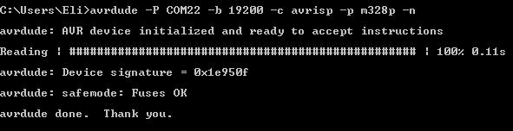

**Figure 3.10** Verifying Connection to Avrdude

You can program now the MCU with the hex file you generated. For example, you have this hex file: newcodenikarl.cpp.hex and it is located in the folder : C:\Users\Eli\AppData\Local\Temp\build2988683827207593850.tmp\, then copy this avrdude command (shown in the first line of Figure 3.11)into the Command Prompt and press enter.

After pressing, this will be displayed in your prompt verifying that a success operation has been made and your avr microcontroller is programmed and ready to execute the code.

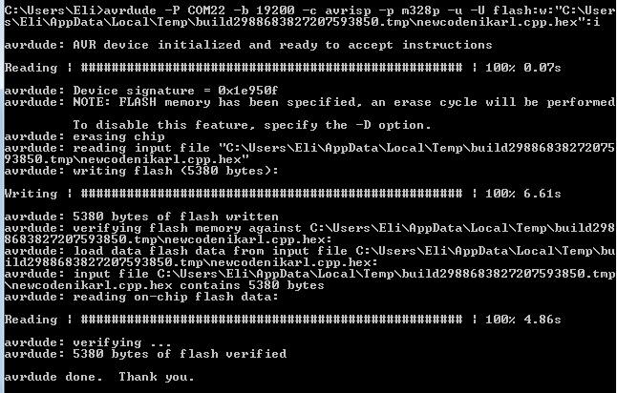

**Figure 3.11** Verifying Operation Success

**3.7 Software Design Process**

Software design is implemented with the combination of the node.js, meteor.js and socket io to better implement data logging with a faster speed process.

**3.7.1 Server and Host Nodes**

The server node has a software system called Meteor JS. Meteor JS allows for the development of the Web Client and an integrated database system called Mongo DB. In addition, Meteor JS has the Distributed Data Protocol. Using Meteor JS’s programming Language called JavaScript, a Publish-Subscribe mechanism is developed that will store and forward real-time data to the Client Node’s Web Browser. The communications system’s software implementation source code is implemented on the Server Node and Host Node.

In the Server Node, there is an exposed function called ‘accumulator’ which is accessible through the Distributed Data Protocol mechanism on top of Web Socket. This ‘accumulator’ function is responsible for receiving updates from Host Nodes and then storing the received data to the Mongo DB database. The web client will then automatically know through DDP that there is an update, and will update the website with new data.

In the Remote Node there is a program called ‘serial port’ which enumerates all serial devices connected to the Remote Node PC. Once the com devices are all enumerated, the Arduino is then selected and automatically, a function that is responsible for listening for serial messages from the Arduino is activated. Once the program receives messages from the Arduino, the DDP client implementation on the Remote Node is triggered to send data using the published ‘accumulator’ function of the Server Node.

The data sent from the Remote Node to the Server Node will include the ‘power’, ‘sender-id’, and ‘receiver-id’. The ‘receiver-id’ will determine the Host Node which the Remote Node will send to. The ‘sender-id’ will identify the sending Remote Node. ‘Power’ is the current power that is read by the ADE7753. The microcontroller will be responsible of organizing this data and sending it via the XBee transmitter that is connected to its UART Port. The data will then arrive at the Host Node, and will be passed to the Server Node.

For demonstration purposes both the Host Node and the Server Node can be in the same computer. In addition, the Client Node can still be the same computer as both Host Node and Serve Node. However, it also possible to record the IP Address of the Server Node, then try to access the Web Client from other Computers acting as Client Node. In addition, the same Server Node IP Address can be used to access the Web Client from a mobile device Client Node.

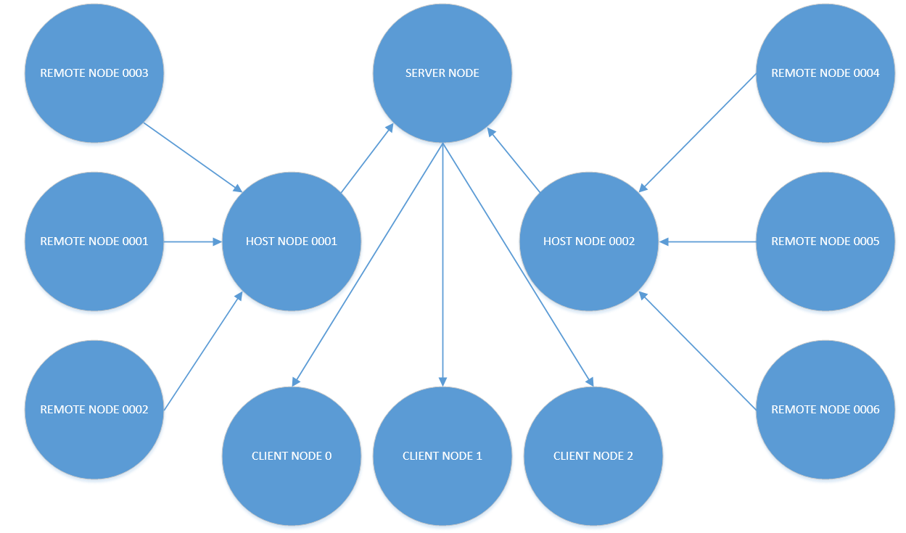

**Figure 3.12** Software Implementation

**3.7.2 Global System for Mobile (GSM) Implementation**

The GSM subsystem works through a delegated SMS messaging service called Telerivet. Once the Server Node has been triggered to send a notification SMS to a client, it will then send an HTTP POST request to a custom server setup in the internet. This server, called SMS Server has the purpose of preparing SMS data for the next server which is the Telerivet Server. The SMS Server compiles the necessary programming and integration with the available Android Phone with a designated SIM. The Telerivet App inside the phone will communicate in real time with the Telerivet Server through their own proprietary API. Once Telerivet Server receives a request for SMS Messaging from the SMS Server, the Phone will download the message parameters. The Android Phone’s own SMS messaging system will then handle the SMS sending using the appropriate parameters set by the Server Node. This way there will be a phone-to-phone communication. The message will then be received by the Client Phone as the 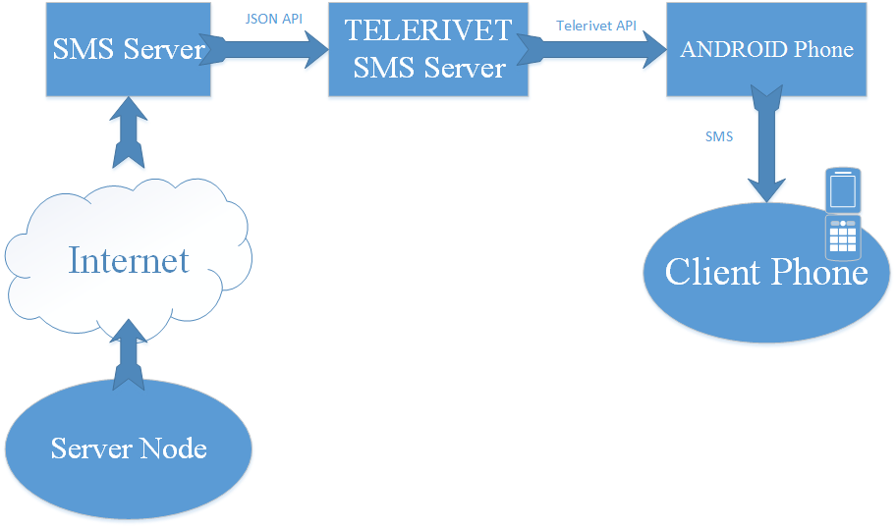Server Node defines.

**Figure 3.13** GSM Framework

**CHAPTER IV**

**RESULTS AND DISCUSSIONS**

This chapter evaluates and describes the results and tests conducted by the researchers after the completion of the ADE7753 metering prototype. The results went as expected with no unusual events that would have introduced an unacceptable percentage error.

It will summarize the process on how the researchers achieve and meet the expected outcome of this study thus verifying the realization of every objectives handed.

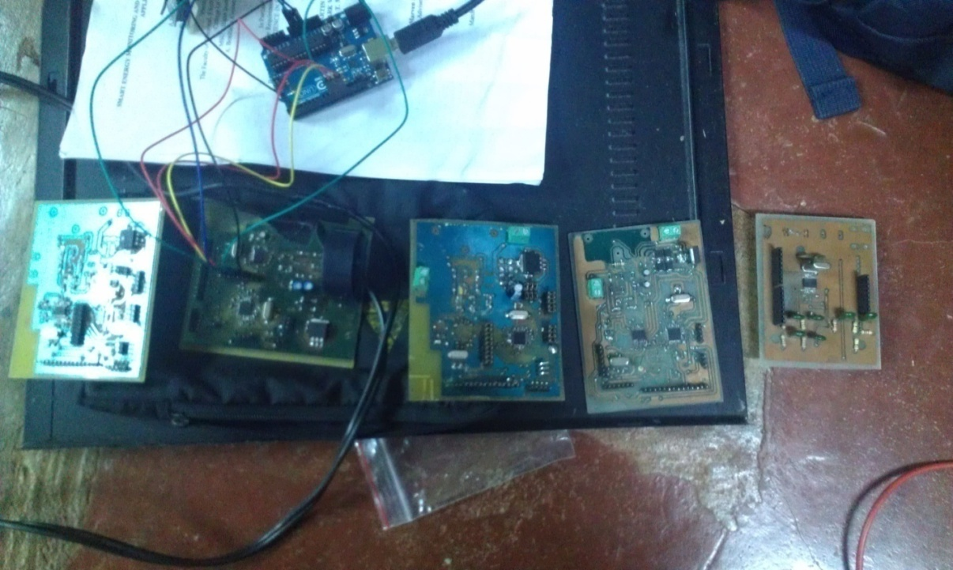

**Figure 4.1** Different Board Manufactured

**4.1 Fabrication Results**

After careful lay outing, designing and fabricating, the final hardware prototype for the device was successfully made. Figure 3 shows Double Sided PCB Layout designed in Cadsoft Eagle PCB Design Software and is implemented in a presensitized double sided Printed Circuit Board which can be bought at e-gizmo.

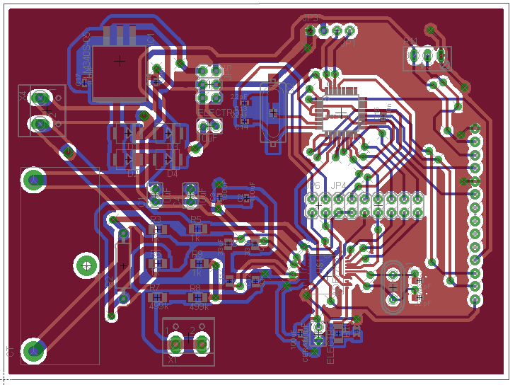

**Figure 4.2** Double Sided PCB Design

The ATMEGA328P and the ADE7753 are taking care of to avoid shorting the pins. The components are carefully soldered since surface mounted types are being used in this project. The preliminary prototype made contains all the components which are integrated to serve for a bigger purpose which is to acquire data and transmit it to the web base application software. The prototype includes the microcontroller used, the ADE7753, surface mounted resistors and capacitors, the current transformer, slots for LCD, surface mounted type 5V regulator, terminal block for the inlet of the ac voltages ( 220V and 12V ac voltage) and for the zigbee pro. This prototype is shown in Figure 4.3.

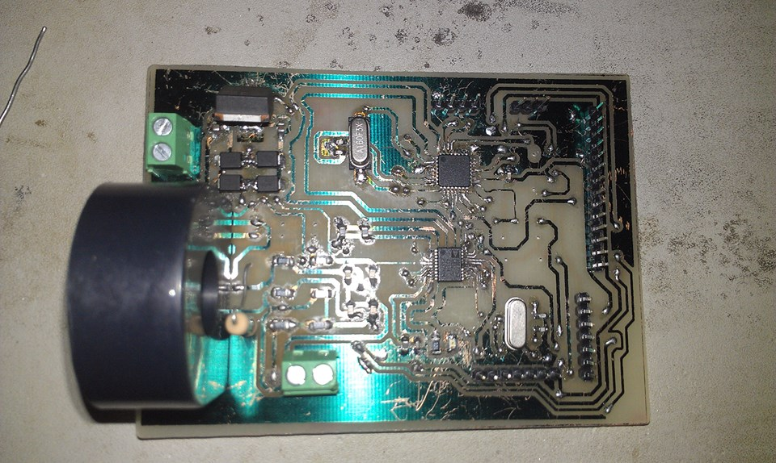

**Figure 4.3** Preliminary Prototype

The actual board for the prototype developed is shown in Figure 4.4 with the Xbee shield and Xbee pro mounted at the top of the board. It also shows the LCD used and the DC fan which will be put in the casing for the cooling effect that will exhaust heat inside the casing.

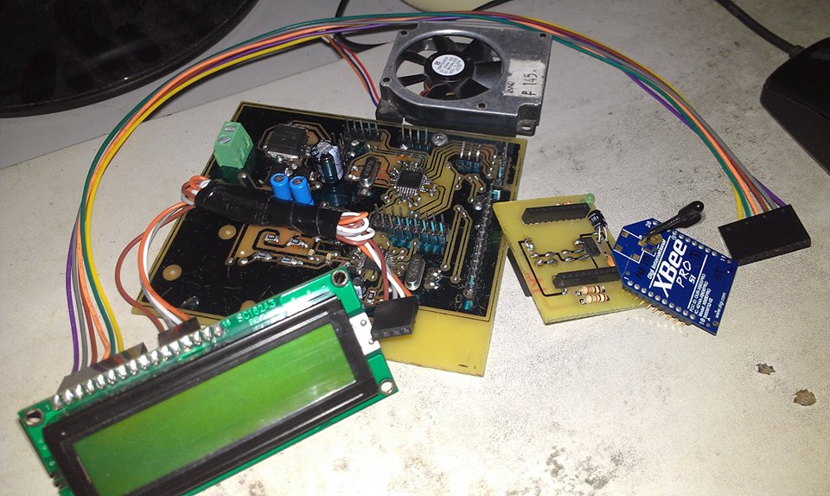

**Figure 4.4** Final Hardware Board

**4.2 Readings Calibration**

The calibration part is very crucial for the total functionality of the prototype. The ADE7753 will produce an output code which is a digital one due to the Analog to Digital Converter (ADC) in every channel responsible for data acquisition in the ADE7753. In order for the prototype to give an actual reading with a least possible error, the output code should be interpreted and converted into its actual value to coincide and meet with the standard of the used digital power meter. This is done by having an appropriate equation that will make all possible output codes inclined with the actual value reading in the power meter to ensure minimal percentage error.

**4.2.1 Output Code from ADE7753**

The output code from the ADE7753 is the initial data to be gathered and analyzed by the researchers towards achieving the actual measurement to be compared in the measurement of the digital power meter. The process is very important to ensure the accuracy and reliability of the made prototype.

The prototype is tested based on the loads which are commonly found in the household or loads which are commonly or somewhat available at most residential houses. These loads are soldering iron, rice cooker, oven, flat iron, and hair dryer. In order to achieve higher current-drawn loads, the researchers combine several loads available.

**4.2.2 Readings from Digital Power Meter**

To have a basis in the actual power, the electrical parameters of every load or combination of loads are being measured by the use of the digital power meter. These parameters are the voltage (in Volts), the current (in Amperes) and the power (in Watts). The digital power meter is capable in measuring these parameters as well as the frequency, the reactive and apparent power. It is also capable in displaying the waveform produced of the voltage and the current to visually analyze the system. But this thing is beyond the knowledge of this study so the researchers did not include it. Shown in the table below is the results for the parameters measured in the power meter for each loadings used.

|  |  |  |  |
| --- | --- | --- | --- |
| Load | Voltage (V) | Current (A) | Power (W) |
| 2 soldering iron | 216.8 | 0.3 | 64.6 |
| rice cooker | 215.8 | 2 | 432.1 |
| 2 soldering iron and rice cooker | 214.8 | 2.3 | 488.8 |
| oven | 214.1 | 3.9 | 842.8 |
| oven and rice cooker | 212.2 | 5.8 | 1233 |
| flat iron | 215 | 4.4 | 946 |
| hair dryer | 220 | 2 | 441.3 |
| flat iron and hair dryer | 214 | 6.2 | 1336 |
| flat iron and oven | 213.7 | 8.3 | 1768 |
| oven, rice cooker and flat iron | 209 | 10 | 2093 |

**Table 4.1** Digital Power Meter Readings

**4.2.3 Initial Readings from ADE7753**

The initial reading from the ADE7753 will be called as the raw data outputted from the ADE7753 prior to the calibration done in the firmware. This data is in a digital format which is the result of the ADC present inside the ADE7753. The knowledge for the raw data is very necessary in this project since this will be the basis for the calibration of the prototype to be able to give reliable results to the user with the assurance of a highest accuracy as possible. These raw data will be outline in the proceeding set of tables which will be given below.

Table 4.2 tabulates the results from the test conducted in the made prototype. The value presented is gathered in a certain time period elapsed.

|  |  |  |  |
| --- | --- | --- | --- |
| Load | Voltage (V) | Current (A) | Power (W) |
| 2 soldering iron | 3687 | 61103 | 100 |
| rice cooker | 3874 | 438738 | 760 |
| 2 soldering iron and rice cooker | 3949 | 500234 | 866 |
| oven | 3683 | 869766 | 1429 |
| oven and rice cooker | 3677 | 1296878 | 2130 |
| flat iron | 3617 | 970845 | 1603 |
| hair dryer | 3813 | 434329 | 713 |
| flat iron and hair dryer | 3790 | 1371266 | 2242 |
| flat iron and oven | 3827 | 1840110 | 3033 |
| oven, rice cooker and flat iron | 3710 | 2236020 | 3688 |

**Table 4.2** ADE7753 Raw Data

**4.2.4 Calibrated Readings from ADE7753**

With the data above, the researchers could now be able to make an equation that can provide an experimental measurement to be compared in the measurement of the digital power meter reading. Finding the appropriate equation is very important to have an experimental measurement inclined to the measurement of the digital power meter with a least possible percentage error thus acquiring a highest possible accuracy to satisfy the user’s needs.

The table below shows the actual and experimental data results with their corresponding error for the voltage measurement.

|  |  |  |  |
| --- | --- | --- | --- |
| Load | Actual Measurement | Experimental Measurement | Percentage Error |
| 2 soldering iron | 216.8 | 210.159 | 3.063191882 |
| rice cooker | 215.8 | 220.818 | 2.325301205 |
| 2 soldering iron and rice cooker | 214.8 | 225.093 | 4.791899441 |
| oven | 214.1 | 209.931 | 1.947220925 |
| oven and rice cooker | 212.2 | 209.589 | 1.230442978 |
| flat iron | 215 | 206.169 | 4.10744186 |
| hair dryer | 220 | 217.341 | 1.208636364 |
| flat iron and hair dryer | 214 | 216.03 | 0.948598131 |
| flat iron and oven | 213.7 | 218.139 | 2.077211044 |
| oven, rice cooker and flat iron | 209 | 211.47 | 1.181818182 |

**Table 4.3** Actual vs. Experimental Voltage Measurement

Table 4.3 will be interpreted clearly in a bar graph as shown in Figure 4.4 to visually see the likeness of the Experimental Voltage Data from ADE7753 Energy Meter to the Actual Voltage Data from Digital Power Meter. The gap between the blue and red one in a particular load will be the percentage error between the two voltage measured in different device. This will also be understood as the accuracy of the device. The smaller the gap, the accurate it is.

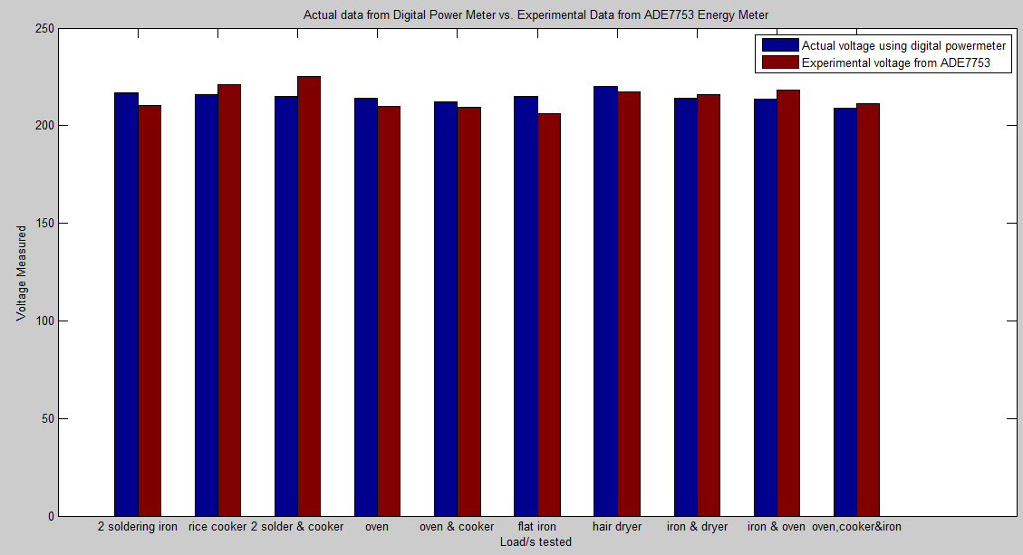

**Figure 4.5** Graphical Interpretation of Voltage Data

The table below shows the actual and experimental data results with their corresponding error for the current measurement.

|  |  |  |  |
| --- | --- | --- | --- |
| Load | Actual Measurement | Experimental Measurement | Percentage Error |
| 2 soldering iron | 0.298 | 0.3127 | 4.932885906 |
| rice cooker | 2.05 | 2.045 | 0.243902439 |
| 2 soldering iron and rice cooker | 2.277 | 2.27 | 0.307422047 |
| oven | 3.936 | 3.9107 | 0.642784553 |
| oven and rice cooker | 5.8 | 5.754 | 0.793103448 |
| flat iron | 4.405 | 4.3745 | 0.692395006 |
| hair dryer | 1.829 | 1.8269 | 0.11481684 |
| flat iron and hair dryer | 6.192 | 6.1419 | 0.809108527 |
| flat iron and oven | 8.273 | 8.2 | 0.882388493 |
| oven, rice cooker and flat iron | 10.01 | 9.92 | 0.899100899 |

**Table 4.4** Actual vs. Experimental Current Measurement

Table 4.4 will be interpreted clearly in a bar graph as shown in Figure 4.5 to visually see the likeness of the Experimental Current Data from ADE7753 Energy Meter to the Actual Current Data from Digital Power Meter. The gap between the blue and red one in a particular load will be the percentage error between the two current measured in different device. This will also be understood as the accuracy of the device. The smaller the gap, the accurate it is.

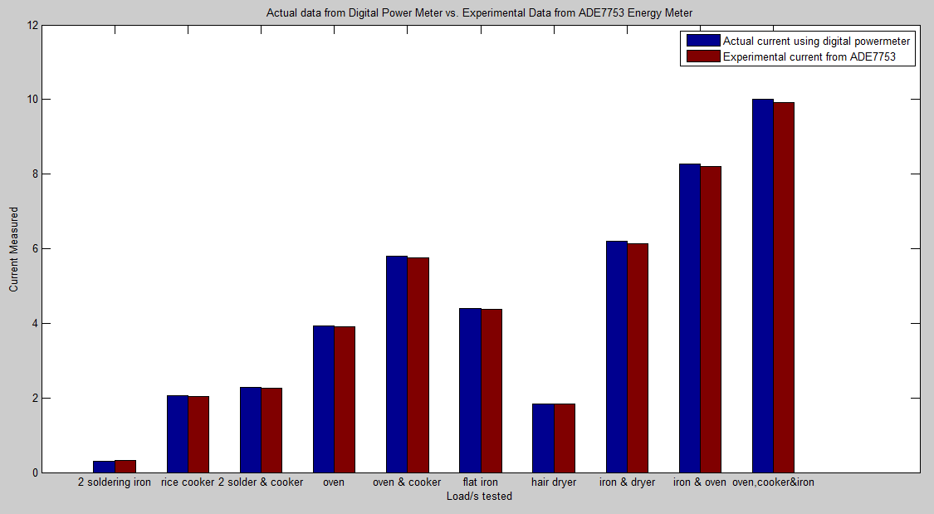

**Figure 4.6** Graphical Interpretation of Current Data

The table below shows the actual and experimental data results conducted after the calibration with their corresponding error for the power measurement.

|  |  |  |  |
| --- | --- | --- | --- |
| Load | Actual Measurement | Experimental Measurement | Percentage Error |
| 2 soldering iron | 64.6 | 67 | 3.715170279 |
| rice cooker | 432.1 | 449 | 3.911131682 |
| 2 soldering iron and rice cooker | 489 | 511 | 4.498977505 |
| oven | 842.8 | 836 | 0.806834362 |
| oven and rice cooker | 1233 | 1241 | 0.648824006 |
| flat iron | 946 | 937 | 0.951374207 |
| hair dryer | 441.3 | 422 | 4.373442103 |
| flat iron and hair dryer | 1336 | 1306 | 2.245508982 |
| flat iron and oven | 1768 | 1763 | 0.28280543 |
| oven, rice cooker and flat iron | 2093 | 2141 | 2.293358815 |

**Table 4.5** Actual vs. Experimental Power Measurement

Table 4.5 will be interpreted clearly in a bar graph as shown in Figure 4.6 to visually see the likeness of the Experimental Power Data from ADE7753 Energy Meter to the Actual Power Data from Digital Power Meter. The gap between the blue and red one in a particular load will be the percentage error between the two powers measured in different device. This will also be understood as the accuracy of the device. The smaller the gap, the accurate it is.

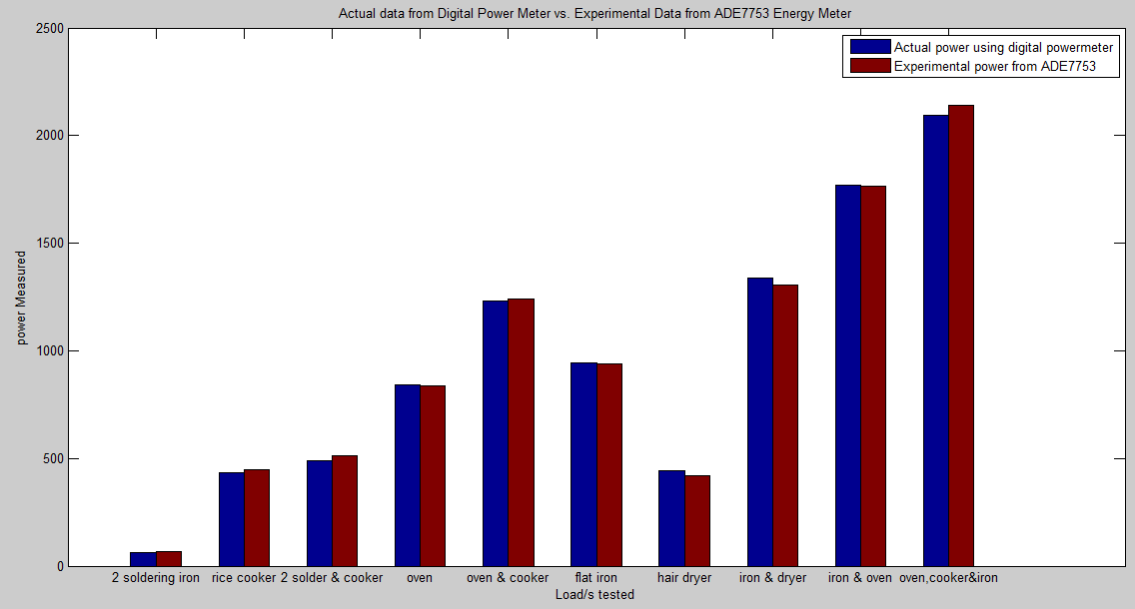

**Figure 4.7** Graphical Interpretation of Power Data

The bar graphs presented are done by the aid of the MATLAB software. Measurements for Current and Voltage are also included since the researchers aim to verify the accuracy of the device when it comes to measuring the current and voltage. Nevertheless, the main concern of this study is only in the power measurement since this will be used in the data logging to the server and the calculation of energy consumption.

All of the loads tested are resistive loadings except for the hair dryer which is an inductive load. The prototype is also tested in a capacitive load using the television set (see attached Compact Disc for the video documentation).

**4.3 Software Implementation**

Demo software was also completed to showcase several features that were documented. The programming development involved Node.JS and Meteor.JS Platform for Reactive Website Development. In addition data was stored on the MongoDB Database. It was shown that the features documented are achievable and the demo site is working. Refer to **Appendix G** for the images of the front end user interface. For the demo of the software, see attached Compact Disc in **Appendix H**.

**CHAPTER V**

**CONCLUSION AND RECOMMENDATIONS**

**5.1 Conclusion**

The researchers were able to develop a system capable of monitoring power consumption with wireless transmission of data. Analog data was converted into digital form through the use of ADE7753 Integrated Chip which is a multi-functionmetering IC capable of measuring electrical parameters such as voltage, current and power. Inside this chip is the Analog to Digital Converter (ADC) and Digital Signal Processing which are responsible for the conversion of an analog signal of not more than 0.5V to an output code in digital format. Since the chip will only accept analog voltage signal, current transformer is used for the conversion of current to voltage signal and a RC filters (Resistors and Capacitors) for the step down of the 220Vac.

Data was transmitted wirelessly through the Zigbee protocol which is a low cost, low power wireless sensor networks. The received data was logged to a database which can be accessed through the internet. The web application developed was able to provide the power consumption for every resident. For the billing assessment, the GSM is utilized to transmit recurring monthly billing updates.

For the disconnection and connection of residential power lines, a two way wireless communication was employed where the server can send a unique code to the prototype for this control line.

The accuracy of the prototype was verified with the aid of a CA8220 Power Analyzer. The percentage error was made sure to comply with the acceptable percentage error range of zero to five percent.

**5.2 Recommendations**

Although the researchers are able to provide preliminary result and setup of the prototype for energy metering of a single phase system, it is still best illustrated in a bigger picture of acquiring the data from node to node in a peer to peer topology basis thus the researcher would like to recommend developing several prototypes to demonstrate this event clearly to attain the best picture of a mesh networking.

The prototype is also best to be tested in a load drawing a higher current to verify the actual output to the theoretical expectation. The researchers are not able to test it due to safety purposes and lack of load resources. Among the loads tested, the maximum current so far is around 10A which is the combination of oven, rice cooker and flat iron.

The researchers would also like to introduce the use of the digital isolator for the Serial Peripheral Interface Bus to isolate the ADE7753 from the microcontroller.

**BIBLIOGRAPHY**

[1] Power(physics).

Retrieved from http://en.wikipedia.org/wiki/Power_(physics).

[2] Zigbee.

Retrieved from http://en.wikipedia.org/wiki/ZigBee.

[3] RWB, June 25,2009. Using Serial Peripheral Interface(SPI) Master and Slave withAtmel AVR Microcontroller.

Retrieved from <http://www.ermicro.com/blog/?p=1050>.

[4] Electronics Tutorial about the Three Phase Transformer.

Retrieved from <http://www.electronics-tutorials.ws/transformer/three->phase-transformer.html.

[5] Analog Devices, “Single-Phase Multifunction Metering IC with di/dt Sensor Interface,” ADE7753 datasheet.

[6] ATMEGA328p

Retrieved from http://www.atmel.com/devices/atmega328p.aspx.

[7] Atmel Studio 6

Retrieved from <http://www.atmel.com/microsite/atmel_studio6/>.

[8] AVRDUDE.

Retrieved from <http://www.nongnu.org/avrdude/>.

[9} Arduino.

Retrieved from <http://www.arduino.cc/>.

[10] Cadsoft Eagle PCB Design Software.

Retrieved from <http://www.cadsoftusa.com/eagle-pcb-design->software/?language=en.

[11] ADMIN, May 7, 2013. AVR LCD Interfacing.

Retrieved from <http://www.zembedded.com/avr->lcd-interfceing-lcd-part-i.

[12] Surface Mount Technology.

Retrieved from <http://en.wikipedia.org/wiki/Surface->mount_technology.

[13] Node.js

Retrieved from <http://en.wikipedia.org/wiki/Nodejs>.

[14] Meteor (Web Framework)

Retrieved from <http://en.wikipedia.org/wiki/Meteor_(web_framework)>

[15] Socket.IO

Retrieved from <http://en.wikipedia.org/wiki/Socket.IO>

[16] Programming a Target AVR using Arduino Uno board loaded with ArduinoISP

Retrieved from <http://pdp11.byethost12.com/AVR/ArduinoAsProgrammer.htm>